PIMPRI CHINCHWAD EDUCATION TRUST'S

PIMPRI CHINCHWAD COLLEGE OF ENGINEERING



**Department of Information Technology**

**Report of Project activity**

**Subject: Data Analysis using R**

**Academic Year 2022-23**

**Semester I**

**Submitted by**  1. Name of the student: Ayush Jain Roll number: SYITA41

Branch: Information Technology

**Submitted to :**

**Date:**

**Sign:**

**Project Title: Descriptive analysis of HR Employee data of MNC Company**

**Data used:** cellphone dataset

**Details of the data :** data set consist of 14 columns containing different attributes of cellphone in total

there are almost 2268 entries

* sale: sale shows units sold
* price: price
* weight: weight of cellphone
* ppi: PPI is no of pixel per inch on screen
* resolution: refers to the number of pixels on a display or in a camera sensor
* cpu.core: No of cores in cpu
* cpu. freq: Frequency of cpu
* internal.mem : It shows Internal memory of device or RAM.
* ram: It is random access memory of cellphone
* battery
* Rear_cam
* Front_cam
* thickness

**Problem stmt 1: Whether price depends on RAM and Internal memory**

correlation between ram, internal memory and price.

|  | RAM | Internal memory | Price |
| --- | --- | --- | --- |
| RAM | 1 | 0.875 | 0.896 |
| Internal memory | 0.875 | 1 | 0.776 |
| Price | 0.896 | 0.776 | 1 |

graph of RAM and price

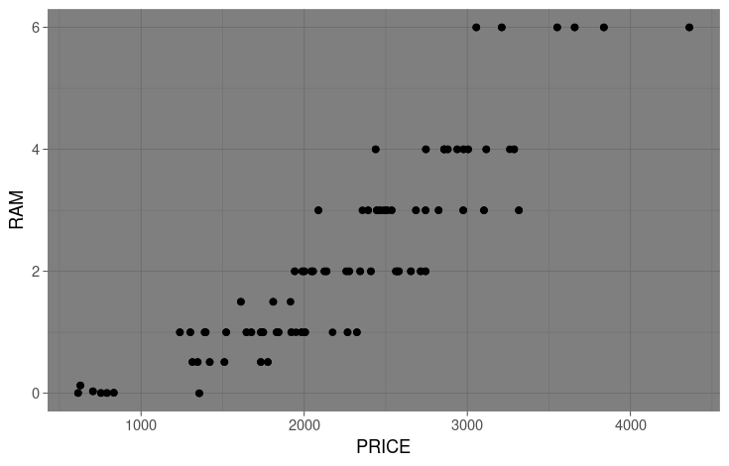

* Here the correlation between ram and price is strong one
* Graph between price and ram shows, price depends on ram
* The graph also shows that price depends on ram but not thoroughly.

**Problem stmt 2: Relation between RAM and Internal memory**

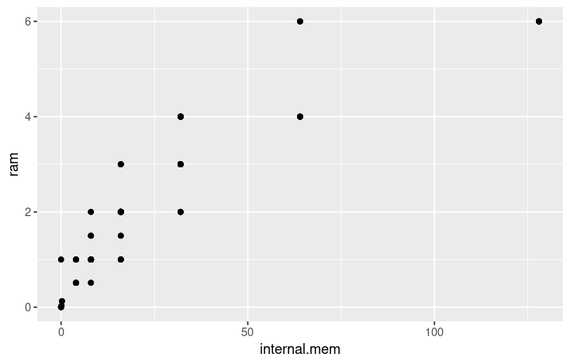

* Given plot shows that as ram increases the internal memory compatible to it increases
* correlation between RAM and internal memory is 0.875 which indicates there is relation between ram and internal memory.

**Problem stmt 3: Does thickness and weight affect the battery.**

* correlation between battery, weight and thickness of cellphone.

|  | weight | battery | thickness |
| --- | --- | --- | --- |
| weight | 1 | 0.8337 | -0.1852 |
| battery | 0.8337 | 1 | -0.412 |
| thickness | -0.1852 | -0.412 | 1 |

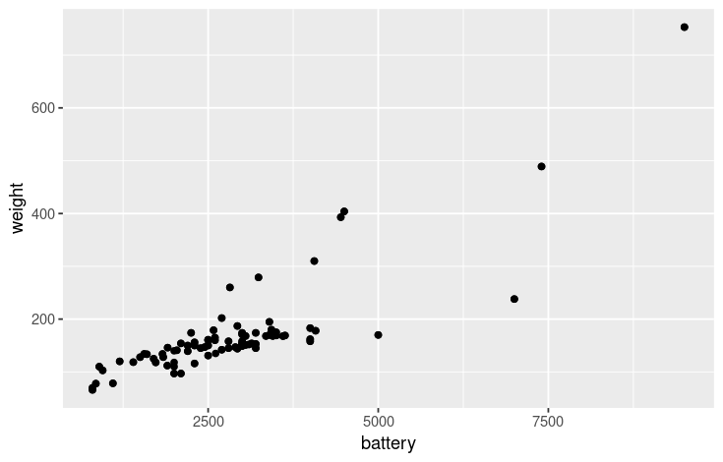

* Battery and weight have strong correlation
* The graph is more concentrated in range 1000 to 3000
* Weight of a cellphone depends on the battery.

**Problem stmt 4: Does sales vary with price, battery, RAM, etc.**

* correlation coefficient of following attributes

|  | Sale | Price | Weight | RAM | Battery |
| --- | --- | --- | --- | --- | --- |
| Sale | 1 | 0.273 | 0.016 | 0.373 | 0.120 |
| Price | 0.273 | 1 | 0.144 | 0.859 | 0.599 |
| Weight | 0.016 | 0.144 | 1 | 0.149 | 0.833 |
| RAM | 0.373 | 0.895 | 0.149 | 1 | 0.541 |
| Battery | 0.120 | 0.599 | 0.833 | 0.541 | 1 |

Scatter plot between sales and price

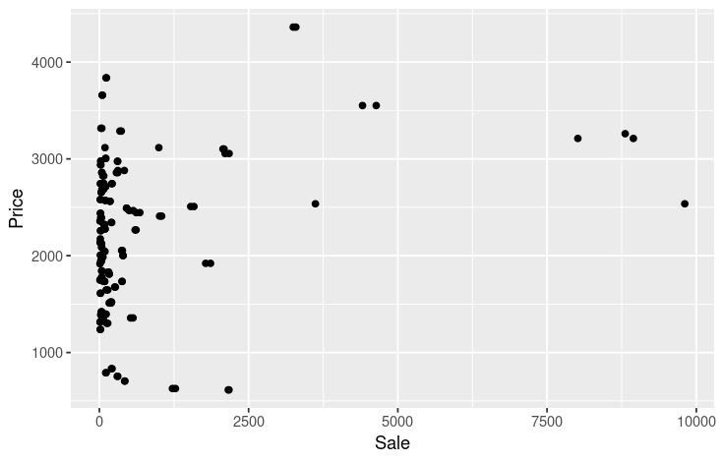

Scatter plot between sales and RAM

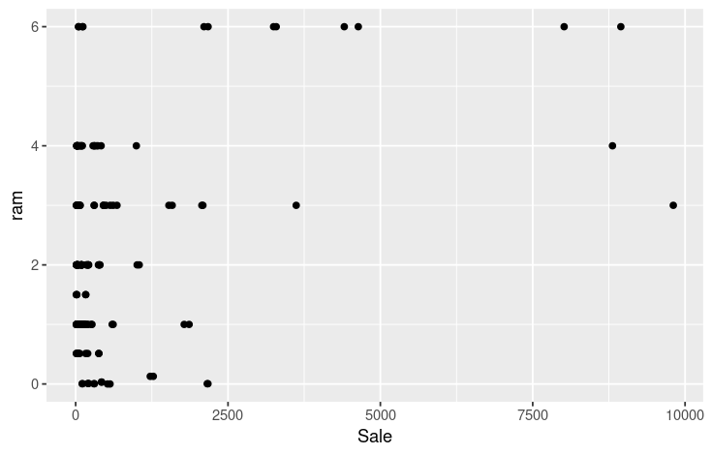

scatter plot between sales and battery

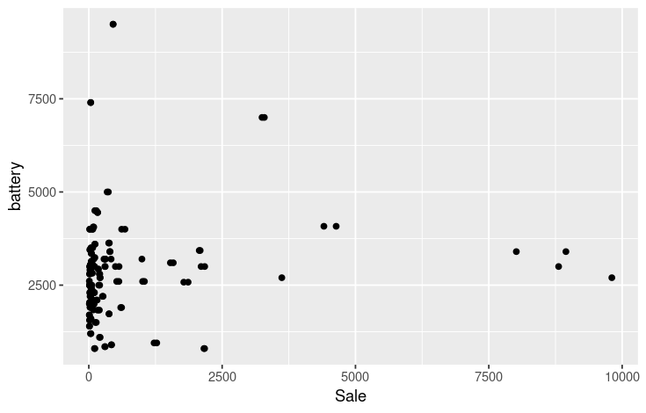

scatter plot between sales and weight

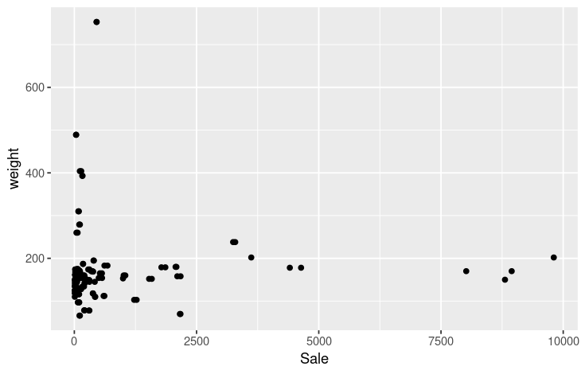

* sales doesn't depend on factors like price, RAM, battery, weight, etc
* so we can assume that sales only depends on popularity of the model.

**Overall Conclusion:**

1. **Price depends on factors like RAM, Internal memory, weight and Battery of cell phone.**
2. **A phone with High RAM needs high Internal memory to be compatible with it.**
3. **Weight of a cellphone depends on the battery. It increases with battery size.**
4. **We had checked for variations of sales with different factors but sales doesn't depend on any factor.**